Jack Mackerel Working Group
  - Terms of Reference adopted at SC13
Table of contents

1 Purpose
The Jack Mackerel Working Group (JMWG) operates under the Scientific Committee (SC) of the South Pacific Regional Fisheries Management Organisation (SPRFMO). Its purpose is to provide scientific advice, analyses, and recommendations on the status and management of jack mackerel (Trachurus murphyi) fisheries in the SPRFMO Convention Area, and to support the SC in fulfilling its mandate to the Commission.
The transition from interim science arrangements to the Commission’s formal SC was drafted in 2006. The JMWG within the SC has been tasked with research and assessment activities related to jack mackerel fisheries (Figure 1).

2 Objectives
The JMWG will:
- Review and analyse data on jack mackerel, including catch, effort, biological, and environmental information.
- Oversee and refine the stock assessment framework for jack mackerel, ensuring it reflects best scientific practice.
- Provide scientific input for the development, evaluation, and implementation of harvest strategies, including management strategy evaluation (MSE).
- Develop, review, and recommend biological reference points and limit and target levels for sustainable management of jack mackerel.
- Identify research priorities, knowledge gaps, and data needs relevant to the stock.
- Facilitate coordination among Members, CNCPs, and observers in contributing data, analyses, and expertise.
- Report findings, analyses, and recommendations to the Scientific Committee in a timely manner.
- Evaluate related species (e.g., chub mackerel, Scomber japonicus) commonly occurring as incidental catch in directed jack mackerel fisheries.

3 Membership
- Participation in the JMWG is open to all Members, CNCPs, and observers of SPRFMO with an interest in jack mackerel science and management.
- Each Member or CNCP may nominate delegates and experts to participate.
- The JMWG may invite external experts to contribute, subject to SC approval.

4 Leadership
- The JMWG shall elect a Chairperson from among its participants in accordance with the SPRFMO Rules of Procedure.
- The Chairperson will serve for a term of two years, renewable once, and will be responsible for guiding JMWG work and liaising with the SC Chairperson and Secretariat.
- The Chairperson should be familiar with stock assessment and data collection practices.

5 Working Arrangements
- The JMWG will conduct its work through intersessional correspondence and collaboration (e.g., Microsoft Teams and email), web meetings, dedicated workshops and technical meetings, and sessions held immediately prior to or during the annual SC meeting.
- The Secretariat will provide technical and administrative support, including document circulation, meeting logistics, and record-keeping.
- All documents and analyses will be prepared in line with SC and Commission protocols, including data confidentiality and standards (e.g., CMM 02).

6 Outputs
The JMWG shall produce:
- Annual or periodic stock assessment reports for jack mackerel.
- Recommendations on harvest strategies, reference points, and management measures.
- Technical papers and working documents on data collection, modelling approaches, and ecosystem considerations.
- A summary of activities, findings, and recommendations for inclusion in the SC annual report to the Commission.

7 Review
These Terms of Reference will be reviewed by the SC every three years, or as required, to ensure they remain fit for purpose and aligned with the evolving needs of the Commission.

8 Historical Organigram
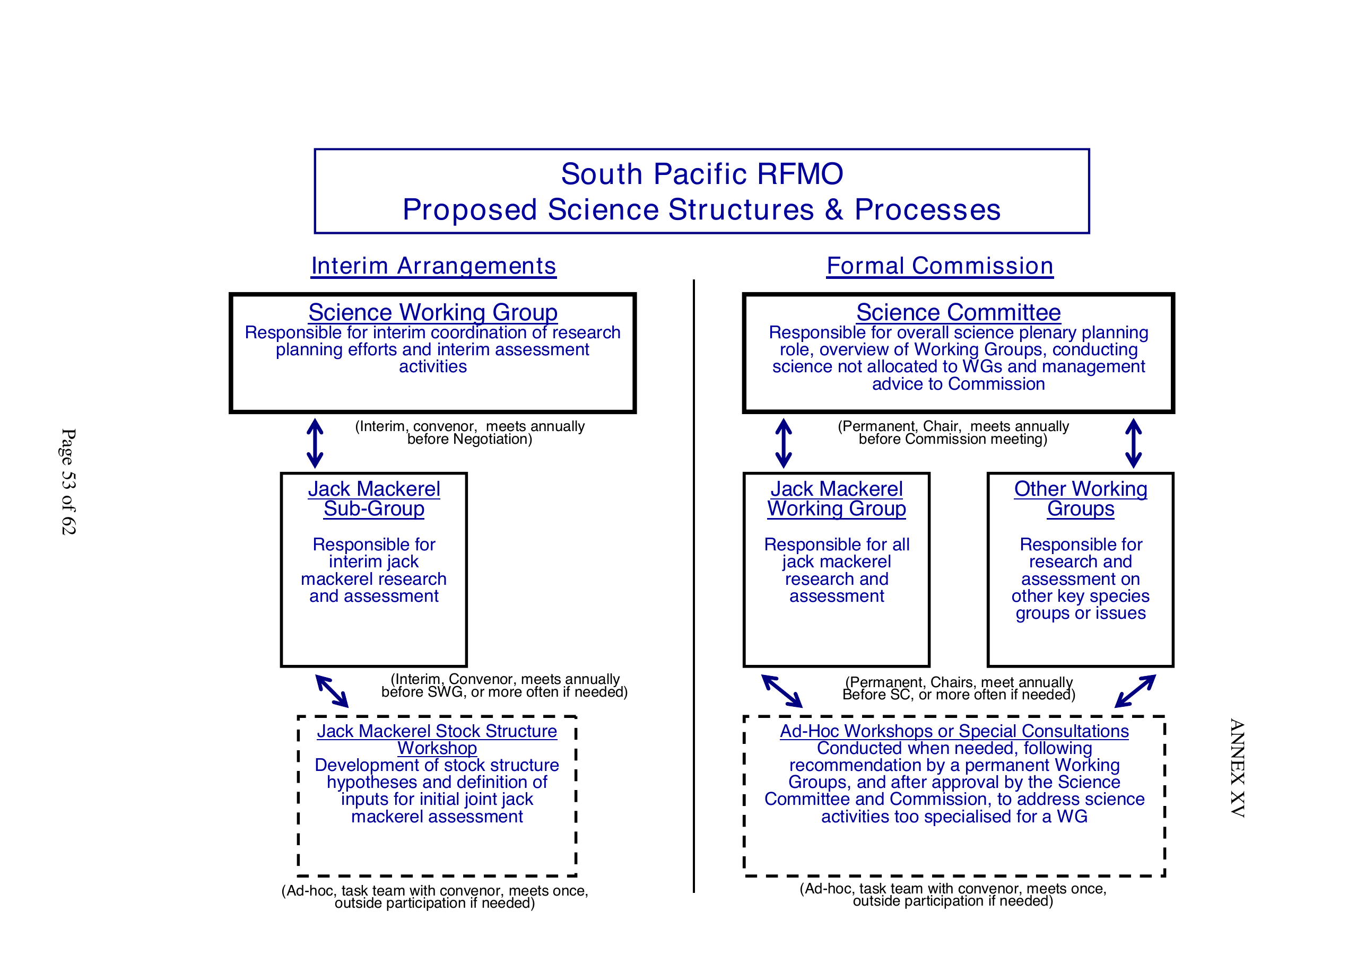
Figure 1: 2006 organigram for Science Working Group, including the JM Working Group.

